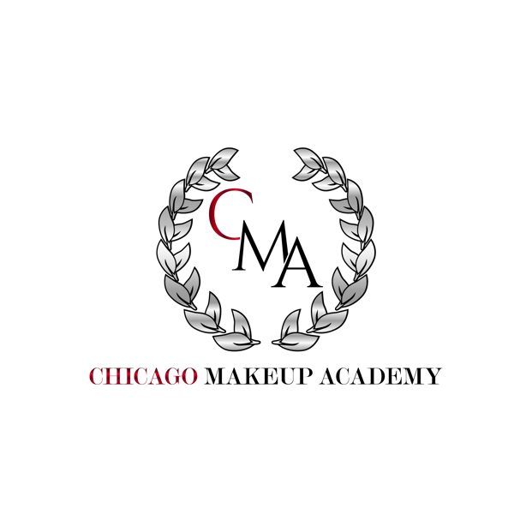

Microshading Academic Catalog

Here at the Chicago Makeup Academy, we strive to provide a friendly and personalized learning environment. Our mission is to create a personable, hands-on experience during each course while also ensuring the proper education and innovation for future growth. We hope to enhance the inner beauty and confidence of our community by using state-of-art practices and superior quality products.

Course Offered

- 2-Day Microshading Course (The course takes place over 2 days for a total of 16 hours.)

Course Information

Our 2-Day Microshading Course is a high-level, advanced seminar that focuses on eyebrow shading techniques. This course will include the teaching of brow mapping and color/skin pigments. Upon completion of the course, each student will receive a certificate of completion. There is a max of 10 students enrolled in each course.

*** This course will include state laws and regulations for microshading. You will learn what is needed for your location to be approved after your state inspection and also receive your Blood Borne Pathogen certification. Also, your instructor will educate you on how to obtain your tattoo license, as well as branding for your new and earned skill. ***

The tuition/deposit is non-refundable and non-transferable. An invoice is sent for the deposit so that the student may enroll in the course and upon arrival of the first day of class, the remaining balance is due via cash or debit/credit card.

Should a student need to cancel or withdraw from the class, the deposit will be forfeited. No exceptions.

Packages Offered

*Regardless of what package a student chooses, they will still be taught the same material and curriculum. The packages below simply show what would be included in a student’s kit upon arrival to class.*

CMA PACKAGE - $2000 ($500 non-refundable deposit)
- CMA labeled microshading kit
CMA VIP PACKAGE - $2500 ($600 non refundable deposit)
- CMA labeled microshading kit
- Head lamp
- Tina Davies Pigment Ink Collection
- Sustaine Face & Body Numbing Gel
CMA VIP PLUS PACKAGE - $3000 ($700 non refundable deposit)
- CMA labeled microshading kit
- Head lamp
- Tina Davies Pigment Ink Collection
- Sustaine Face & Body Numbing Gel
- Massage Bed
- Plastic Bed/Cart Protector

Admission Requirements

- Student must be at least 18 years of age or older
- Must choose from one of the above listed packages and pay non-refundable deposit

Withdrawal/Transfer

The student has the right to cancel the initial enrollment agreement until 5p of the 7th business day after the student has been admitted. If the right to cancel is not given to any prospective student at the time the agreement is signed, then the student has the right to cancel the agreement at any time and receive a refund on all monies paid to date within 14 days of cancellation. Cancellation should be submitted to the authorized official of the school in writing.

Students should do research on any institution that may offer the Microshading course as each instructor is different and the curriculum may be unique to that institution. Chicago Makeup Academy’s program isn’t one where a student can transfer or seek higher education using the certificate of completion earned at CMA.

Complaints

Individuals seeking to register a complaint about an Illinois higher education institution are required to register a complaint using IBHE’s Institutional Complaint System. Complaint processing as it relates to maintenance of institutional approvals is described in 23 Illinois Administrative Rules Sections 1030.70, 1030.80, and 1095.250.
The Board receives general information email at info@ibhe.org.
Students seeking to register a complaint about an institution are required to submit the complaint in writing. Complaint processing as relates to maintenance of institutional approvals is described in 23 Illinois Administrative Rules Sections 1030.70 and 1030.80.

http://complaints.ibhe.org/

Disclosure (1095.240)

No paid enrollments during July 1st, 2019-June 30th, 2020. Pending approval of IBHE. Because of this, there aren’t any numbers of past or present students to report on.

- Chicago Makeup Academy is not accredited by a US Department of Education recognized accrediting body.

2022 Microshading Calendar

January | 1/9-1/10
February | 2/6-2/7
March | 3/6-3/7
April | 4/10-4/11
May | 5/15-5/16
June | 6/5-6/6
July | 7/10-7/11
August | 8/7-8/8
September | 9/4-9/5
October | 10/9-10/10
November | 11/6-11/7
December | 12/4-12/5

- Chicago Makeup Academy is approved to operate by the Private Business and Vocational Schools Division of the Illinois Board of Higher Education.*

